NAVISTAR CSO | Standard Operating Procedure | Instruction Author:  Navistar Education
Date Last Updated:  22 April 2022 | Title:  Accessing the Supplier Quality Training Portal | Version Number:  1.0
Change Log:

Table of Contents
Description 1
Reference Information 1
Creating an account 2
Enrolling in courses 4

Description
This document will cover how to create an account on the Supplier Quality training portal and enroll in the needed training.

Reference Information
URL for the Supplier Quality training portal: https://www.navistareducation.com/ihtml/application/student/interface.navistar/indexSupplier.htm

Creating an account
- Start by going to the Supplier Quality training portal linked in the Reference Information section. You can confirm you are accessing the correct portal by the blue banner at the top of the page.
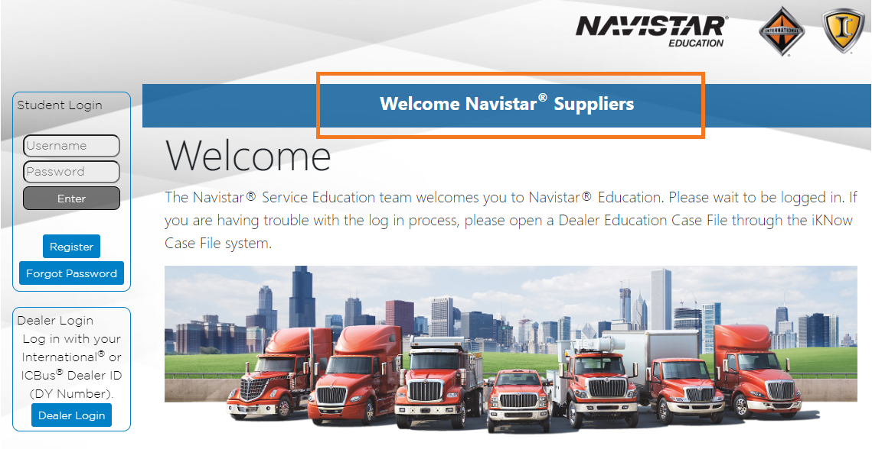
- Select Register to enter your information.
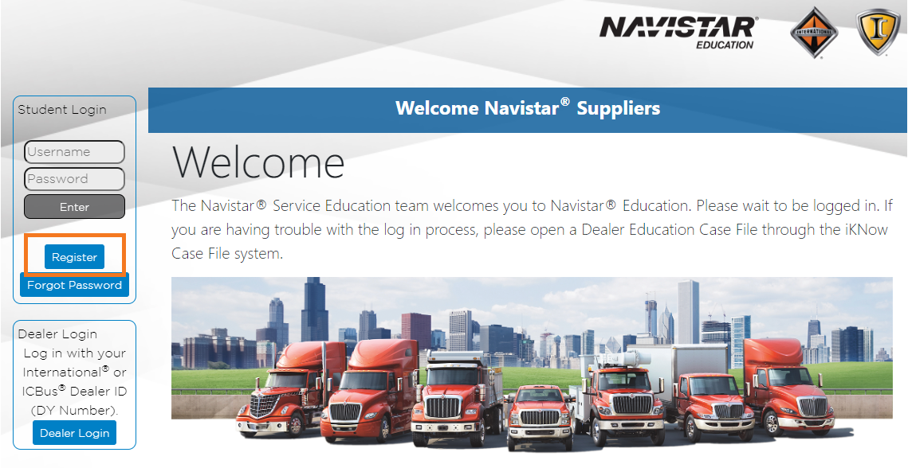

- Enter your full name, company email address, company name, Navistar supplier code, job title, a username, a password, and select your country and state / province.
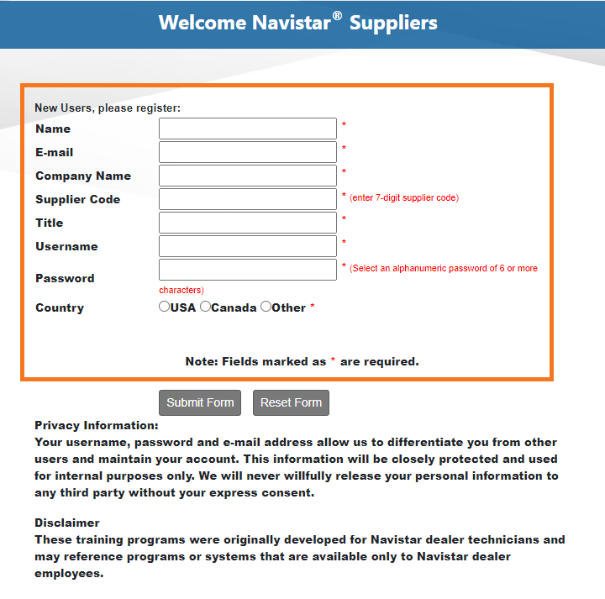
- Select Submit Form to create your account and access the portal.

Enrolling in courses
- Select Course Catalog from the menu on the left.
- Select the Supplier Quality Training Courses catalog from the list.
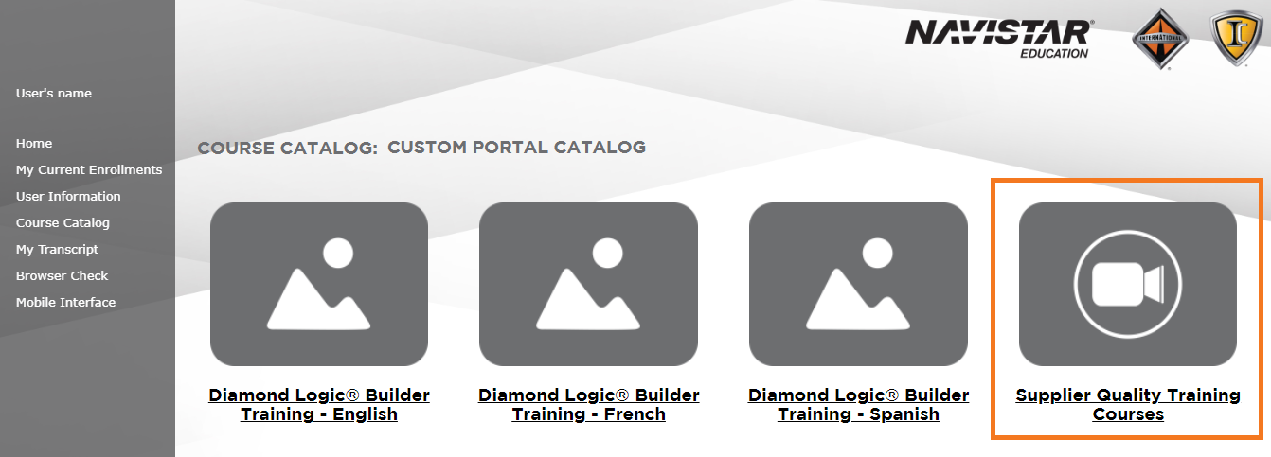
- Select the course you would like to enroll in. Please note that course must be taken in order.
- Once enrolled, go to the My Current Enrollments page to launch the training.
- To enroll in additional courses, repeat steps 1 through 4.

