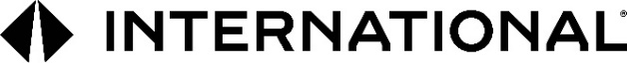

**International Motors, LLC\***

2701 Navistar Drive

Lisle, IL 60532 USA

P: 331-332-5000

W: international.com

**Subject: Notification of Name Change**

Dear Valued Business Partner,

Effective October 1, 2024, our company name has changed from Navistar, Inc. to **International Motors, LLC\***. Please update your records to reflect our new name for all future invoices and payments and notify all relevant departments and personnel within your company. Please note that we will also have a new website: [www.international.com](http://www.international.com). Our billing address and email addresses remain the same for now.

Please note that with the only change being the name of our company, the change does not affect any existing agreements or our terms or conditions. We kindly request you address all future correspondence and all import and/or export shipping documentation to our new company name. Should you have any questions or need further clarification regarding this change, please do not hesitate to contact us.

In Canada, effective October 1, 2024, our company name has changed from Navistar Canada ULC to International Motors Canada ULC**. In Mexico, effective September 25, 2024, our company name has changed from NAVISTAR MEXICO, S. DE R.L. DE C.V. To INTERNATIONAL MOTORS MEXICO CV, S. DE R.L. DE C.V.

Thank you for your understanding and cooperation. We look forward to our ongoing relationship under our new name.