**Navistar Application Login Screen Changes**

**Effective February 3, 2020,** add @Navistar.com to the end of your id to login to Navistar applications. Password will remain the same.

For example: S123456789 is now S123456789@Navistar.com.

Please contact Supplier Support at 800-527-7879 with any questions.

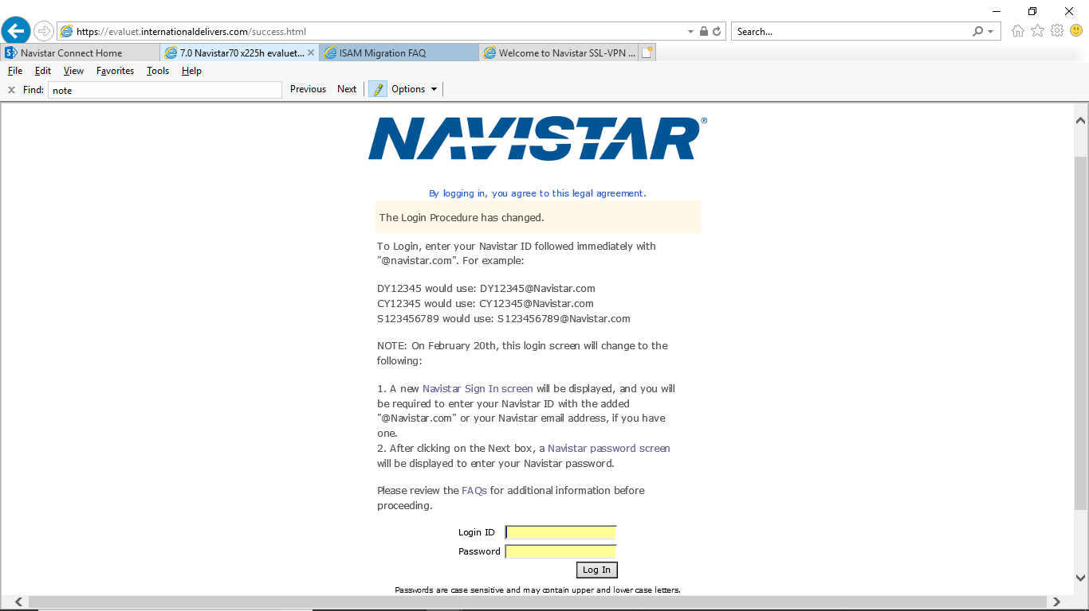

**Effective February 20, 2020,** the login screen will change to a two-step process with two new screens.

1. A new Navistar Sign In screen will be displayed, and you will be required to enter your Navistar ID with the added “@Navistar.com”.

2. After clicking on the Next box, a Navistar password screen will be displayed to enter your Navistar password.

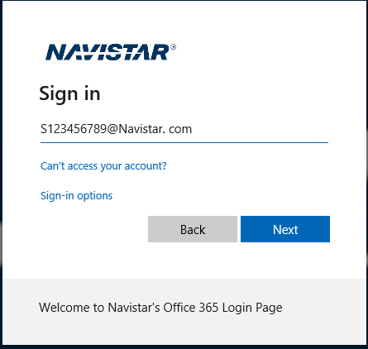

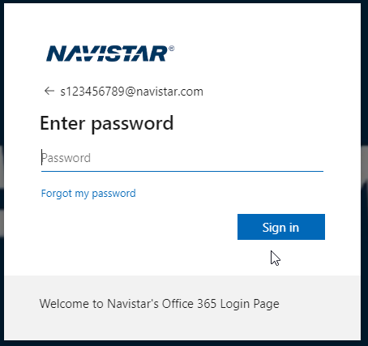

**FAQs**

If you get error code HPDIA0115E:

Clear your browser cache, close your browser, then open a new browser and try logging in again. If that doesn’t work, please contact Supplier Support at 800-527-7879.